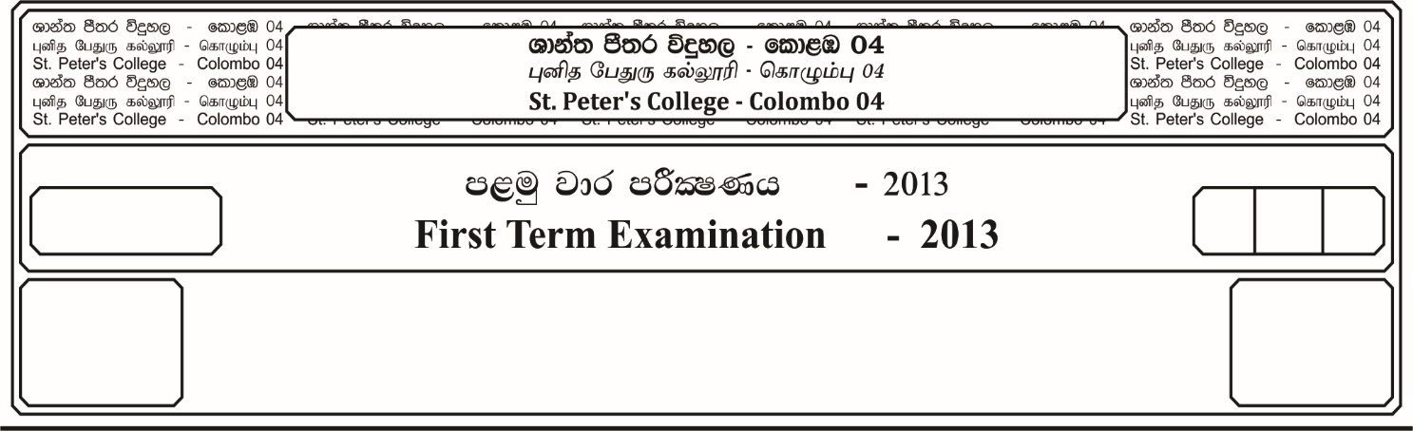

13 fY%aKsh

GRADE 13

E

$03$ meh

$03$ Hour

I

**fojk jk jdr mÍCIKh - 2023**

**Second Term Examination - 2023**

ixhqla; .Ks;h - ¸

**COMBINED MATHEMATICS – I**

10

* **Answer all the questions of Part A and any 05 questions of Part B.**

**Part -A**

01. By using the principle of Mathematical Induction prove that,

……….  **1 - , n N**

02. If **,**  are the roots of the equation ${ρx}^{2}$ $+$ $qx$ $+$ $r$ $=$**0**, then find the value of

03. If  then show that

04. If  then show that  **e**

05. Find the value of the real non-zero constant ***K*** such that  **1**

06. Sketch the graphs of the functions **y = ${(x-2)}^{2}$**  and **y = 4 - 2*x*** in the same coordinate plane. Show that the area bounded by these graphs is $4/3$ squre units.

07. A curve is defined by equations ***x* = $t^{2}$**  and **y = ${at}^{3}- t^{2}$**  , where $a ∈R^{+}$**.** If the tangents drawn to the curve at the points given by **t = 1** and **t = -1** are peroendicular to each other, find the value of ***a****.*

08. Integrate  **dx**, where where

09. In how many ways can be the word **“PENCIL”** be arranged so that **N** is always next to **E**.

10. Show that $3 {Sin}^{-1} x$ **= ${Sin}^{-1}$ (3*x* - ${4x}^{3}$)**

**Part – B**

**Answer any five (05) questions.**

11. a). If the roots of the equation, $x^{2}$ $+$**2 (P + 2) x + (2P + 7) = 0** are $∝$ and $β$.

Express, $\left\{∝^{3}+2 \left(P+2\right) β^{2}\right\}$ $+$ $\left\{β^{3}+ 2 \left(P+2\right) ∝^{2}\right\}$ in terms of ***P***

If $P_{1}$ and $P_{2}$ are the values of $ρ$ when,

$\left\{∝^{3}+2 \left(P+2\right)β^{2}\right\}$ $+$ $\left\{β^{2}+2 \left(P+2\right) ∝^{2}\right\}$**= 56**

With out finding $p_{1}$ and $p_{2}$ Seperately, Prove that $\frac{(P_{1}-3) (P_{2}-3)}{\left(p_{1}+2\right) (p_{2}+2)}$ **= $\frac{- 37}{28}$**

b). Let $\left(x\right)= {2x}^{3}+ {5x}^{2}+ax+b$, where ***a*** and **b** are constants.

It is given that $(2x + 1)$ is a factor of $P(x)$ and that when $P(x)$ is divided by $(x+2)$, the remainder is ***a***.

i. Find the values of ***a*** and ***b***.

ii. For these values of $a$ and $b$, factorise $P(x)$ completely.

12. a). Find the set of values of $x$ satistying the inequality **| | | |** , where ***a*** is a positive constant.

b). Given that $\left(r\right)= \frac{1}{r^{2}}$, show that $f\left(r\right)-f\left(r+1\right)=$ $\frac{2r+1}{r^{2} ({r+1)}^{2}}$.

Let $S_{n}$ be the sum of n terms of the series,

$\frac{2}{1^{2} 2^{2}}$ $+$ $\frac{5}{2^{2} 3^{2}}$ $+$ $\frac{7}{3^{2} 4^{2}}$…. $n (n+2)$

Show that $S_{n}=$ $\frac{n (n+2)}{{(n+1)}^{2}}$

Hence show that,

$\sum_{r=1}^{∞}{U_{r}}$, is convergent and find its Sum, Where $U_{r}$ is the general term of the series.

13. a). If  then show that,

$A^{2}-5A+7 I=O$

Hence find $A^{-1}$

b). The complex number $\frac{2}{- 1+i}$ is denoteol by ***U***,

i. Find the modulus and argument of ***U*** and $U^{2}$

ii. Sketch an Argand diagram showing the points representing the complex numbers ***U*** and $U^{2}$. Shade the region whose points represent the complex numbers ***Z***, Which satisfy both the inequalities **| Z | <2** and **| Z - | < | Z - U |** .

14. a). The curve with equation, $y= \frac{ax+b}{x (x+2)}$ where ***a*** and **b** are constants, has zero gradient at the point $(1 , -2)$

i. Show that $a= -8$ and find the value of **b**.

ii. Show that the gradient is also zero at the point $(-1/2 , -8)$

iii. Find for three asymptotes of this curve.

Sketch the curve stating the coordinates of the points at which the curve meets the

$x - axis$,

Using the sketch find the set of values of **y** for which no part of the curve exists.

b). The plane ends of right circular solid cylinder of height ***h*** and radius ***r*** are scooped out to form a hollow hemispherical surface of radius ***r***. If the volume of the remaining part is ***V***, and the total surface are is ***S***, then show that,

$S=$ $\frac{2V}{r}$**+ $\frac{20 πr^{2}}{3}$**

Find the value of ***r*** that the surface area ***S*** be minimum.

Also find the minimum surface area.

15. a). Using partial fractions, show that,

$\int_{o}^{1}{\frac{dx}{\left( 1+x\right)(1+ x^{2}) }}$**= $π/8$ $+$ $\frac{1}{4}$ $ln2$**

b). By using intergration by parts, evaluate.

$\int{x}$ $\sin^{-1} x dx$

c). Using the substitution $\tan{x=t}$, Show that

**=**

16. a). The points $A (-4,6)$ and $c (-1,1)$ are opposite vertices of a parallelogram $ABCD$. The sides $BC$, $CD$ of the parallelogram lie along the lines $x+3y-2=0$ and

$x-y+2=0$**.** Calculate,

i. The coordinates of ***D***

ii. The tangent of the acute angle between the diagnonals parallelogram.

iii. The length of the perpendicular from ***A*** to the side ***CD***.

iv. Show that the area of the **ABCD** is **24 unit $s^{2}$**

b). Find the values of c such that the line $x+y=c$, shall be a tangent to the circle

$x^{2}+ y^{2}-4x+2=0$. For each value of ***c*** find the coordinates of the point of contact. Draw a sketch of the circle and the two tangents.

17. a). Prove the identity,

$tan θ+\cot{θ=2}$ $cosec 2θ$.

Find the solutions of the equation,

$tan x+\cot{x=8 cos 2x}$, in the range $0<x< π$

b). In the usual notation, state the sine rule for a trangle **ABC**.

In any triangle **ABC** prove that,

$tan$ $\frac{(A-B)}{2}$**= $\frac{(a-b)}{(a+b)}$ cot $\frac{c}{2}$**

c). Solve for $x$,

$\tan^{-1} 2x + \tan^{-1} x= \cot^{-1} 4 (1-{2x}^{2})$